**ASSIGNMENT 4**

***Q1. Write a C program to print Hello Students on the screen.***

*#include <stdio.h>*

*int main()*

*{*

*printf("Hello Students");*

*return 0;*

*}*

***Q2. Write a C Program to print Hello on the first line and Students in the second line.***

*#include <stdio.h>*

*int main()*

*{*

*printf("Hello\nStudents");*

*return 0;*

*}*

***Q3. Write a C program to print “MySirG” on the screen.***

*#include <stdio.h>*

*int main()*

*{*

*printf("\"MySirG\"");*

*return 0;*

*}*

***Q4. Write a C program to print “Teacher’s Day” on the screen.***

*#include <stdio.h>*

*int main()*

*{*

*printf("\"Teacher's Day\"");*

*return 0;*

*}*

***Q5. Write a C program to print \n on the screen.***

*#include <stdio.h>*

*int main()*

*{*

*printf("\\n");*

*return 0;*

*}*

***Q6. Write a C program to print %d on the screen.***

*#include <stdio.h>*

*int main()*

*{*

*printf("\\d");*

*return 0;*

*}*

***Q7. Write a C program containing declaration of three variables (of type int, char and float), also assign some values to them and print values of all three variables using single printf().***

*#include <stdio.h>*

*int main()*

*{*

*int a=8;*

*char b='B';*

*float c=4.6;*

*printf("a=%d b=%c c=%f",a,b,c);*

*return 0;*

*}*

***Q8. Explore following format specifiers on internet - %i, %g, %lf .***

|  |
| --- |
|  |

*Behavior of %d and %i is different in scanf.*

*%d assume base 10 while %i auto detects the base. Therefore, both specifiers behaves differently while they are used with an input specifier.*

*So, 012 would be 10 with %i but 12 with %d.*

* *%i -> a decimal integer that detects the base automatically*
* *%g -> it is used to print the decimal floating-point values, and it uses to fixed precision, i.e., the value after the decimal in input would be exactly the same as the value in the output.*
* *%lf -> It is used in printf to print value with double data type.*

***Q9. Write a C program to print character stored in a char variable, also print its ASCII code.***

*#include <stdio.h>*

*int main()*

*{*

*char a='A';*

*printf("character=%c ASCII=%d",a,a);*

*return 0;*

*}*

***Q10. How to convert a Decimal number into a Binary number and vice versa.***

*Decimal number is a base 10 number because it ranges from 0 to 9, there are total 10 digits between 0 to 9. Any combination of digits is decimal number such as 23, 445, 132, 0, 2 etc.*

*Binary number is a base 2 number because it is either 0 or 1. Any combination of 0 and 1 is binary number such as 1001, 101, 11111, 101010 etc.*

*Steps to convert a number from decimal to binary:*

* *Step 1: Divide the number by 2 through % (modulus operator) and store the remainder in array.*
* *Step 2: Divide the number by 2 through / (division operator).*
* *Step 3: Repeat the step 2 until number is greater than 0.*

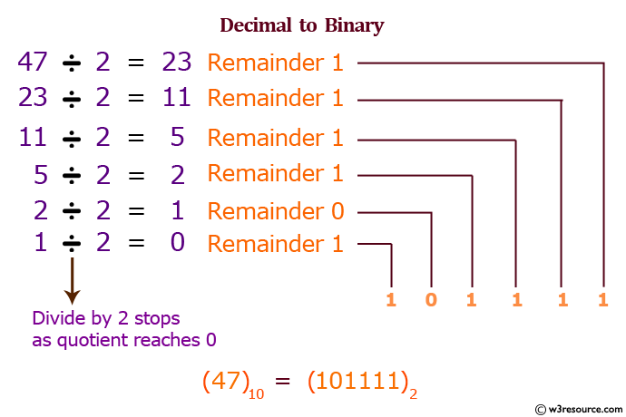

*Steps to convert a number from binary to decimal:*

* *Step 1: Write down the binary number.*
* *Step 2: Starting from the left, double your previous total and add the current digit.*
* *Step 3: Double your current total and add the next leftmost digit.*
* *Step 4: Repeat the previous step.*

